Lab 4

***CSS LISTS***

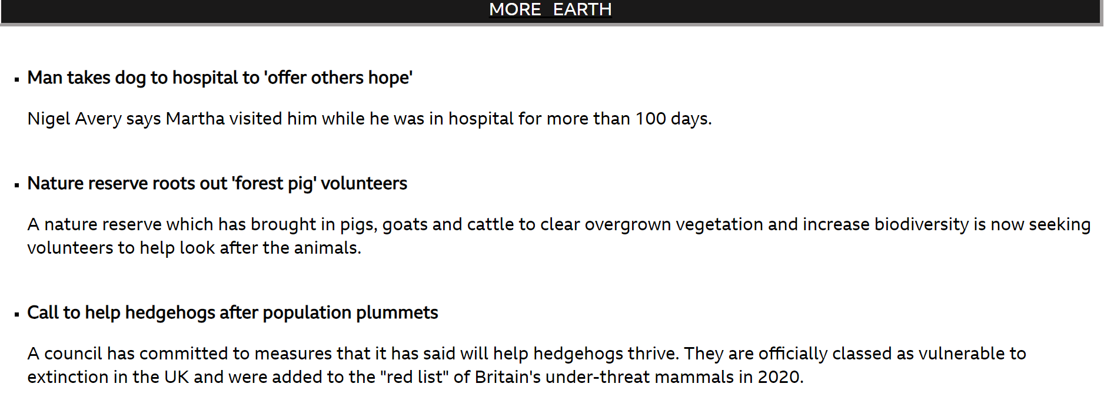

ul.b

{

list-style-type: square;

}

<ul class="b">

              <li>

                  <strong>Man takes dog to hospital to 'offer others hope'</strong>

                  <p>Nigel Avery says Martha visited him while he was in hospital for more than 100 days.</p>

              </li>

              <br>

              <li>

                  <strong>Nature reserve roots out 'forest pig' volunteers</strong>

                  <p>A nature reserve which has brought in pigs, goats and cattle to clear overgrown vegetation and increase biodiversity is now seeking volunteers to help look after the animals.</p>

              </li>

              <br>

              <li>

                  <strong>Call to help hedgehogs after population plummets</strong>

                  <p>A council has committed to measures that it has said will help hedgehogs thrive. They are officially classed as vulnerable to extinction in the UK and were added to the "red list" of Britain's under-threat mammals in 2020.</p>

              </li>

          </ul>

***PADDING***



.topnav a

{

  float: left;

  display: block;

  color: #f2f2f2;

  text-align: center;

  padding: 14px 70px;

  text-decoration: none;

}

<div class="topnav">

    <a href="file:///C:/Users/Adharv%20p%20p/OneDrive/Pictures/HTML/home%20page%20copy.html">HOME</a>

    <a href="file:///C:/Users/Adharv%20p%20p/OneDrive/Pictures/HTML/sports.html">SPORTS</a>

    <a href="file:///C:/Users/Adharv%20p%20p/OneDrive/Pictures/HTML/BUSINESS.html">BUSINESS</a>

    <a href="file:///C:/Users/Adharv%20p%20p/OneDrive/Pictures/HTML/innovation.html">INNOVATION</a>

    <a href="file:///C:/Users/Adharv%20p%20p/OneDrive/Pictures/HTML/culture.html">CULTURE</a>

    <a href="file:///C:/Users/Adharv%20p%20p/OneDrive/Pictures/HTML/travel.html">TRAVEL</a>

    <a href="file:///C:/Users/Adharv%20p%20p/OneDrive/Pictures/HTML/earth.html">EARTH</a>

  </div>

*RESPONSIVE DESIGNING*

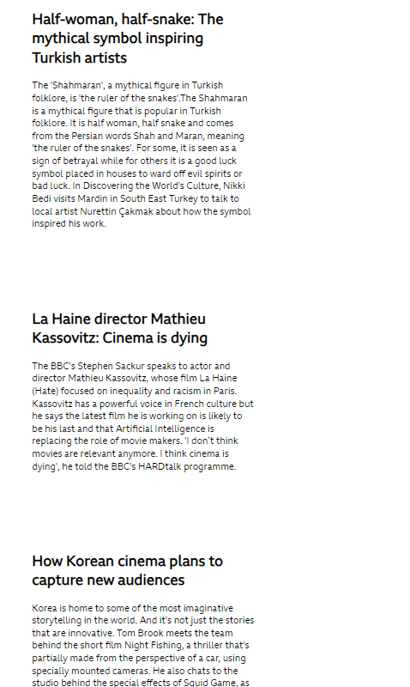

 <meta charset="utf-8">

  <meta name="viewport" content="width=device-width, initial-scale=1.0">

@media screen and (max-width:100px)

 {

  .column {

    width: 100%;

  }

}

<div class="row">

    <div class="column">

        <h2 style="font-size: 25px;">Half-woman, half-snake: The mythical symbol inspiring Turkish artists</h2>

        <p style="font-size: 16px;">The 'Shahmaran', a mythical figure in Turkish folklore, is 'the ruler of the snakes'.The Shahmaran is a mythical figure that is popular in Turkish folklore. It is half woman, half snake and comes from the Persian words Shah and Maran, meaning 'the ruler of the snakes'. For some, it is seen as a sign of betrayal while for others it is a good luck symbol placed in houses to ward off evil spirits or bad luck.

        In Discovering the World's Culture, Nikki Bedi visits Mardin in South East Turkey to talk to local artist Nurettin Çakmak about how the symbol inspired his work.</p>

    </div>

    <div class="column">

      <h2 style="font-size:25px;">La Haine director Mathieu Kassovitz: Cinema is dying</h2>

      <p style="font-size:16px;">The BBC's Stephen Sackur speaks to actor and director Mathieu Kassovitz, whose film La Haine (Hate) focused on inequality and racism in Paris. Kassovitz has a powerful voice in French culture but he says the latest film he is working on is likely to be his last and that Artificial Intelligence is replacing the role of movie makers. 'I don’t think movies are relevant anymore. I think cinema is dying', he told the BBC's HARDtalk programme.</p>

    </div>

    <div class="column">

        <h2 style="font-size:25px;">How Korean cinema plans to capture new audiences</h2>

        <p style="font-size:16px;">Korea is home to some of the most imaginative storytelling in the world. And it's not just the stories that are innovative.

            Tom Brook meets the team behind the short film Night Fishing, a thriller that's partially made from the perspective of a car, using specially mounted cameras.

            He also chats to the studio behind the special effects of Squid Game, as well as Oscar-winner Parasite, and finds out what impact AI will have on Korean storytelling in the near future.</p>

    </div>

  </div>